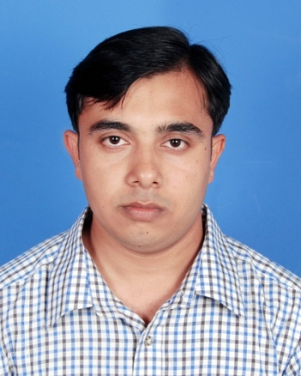
Syful Islam
Address: 127, Boro Boyra, Pal Para road, Boyra, Khulna
Mobile No: 01912707244, 01798774433
E-mail: syfulislamrepon@gmail.com

Career Objective

Building up a career in a national or multinational organization where creativity, sincerity, skill and performances are the criteria for one’s appraisal. To work meaningfully through consistency, discipline and hard work in creative and competitive environment based on strong commitment.

Educational Background

Masters in Business Administration | Institution | : | Khulna University
Masters in Business Administration | Discipline | : | Business Administration
Masters in Business Administration | Major | : | Finance
Masters in Business Administration | Result | : | 3.62 out of 4.0
Masters in Business Administration | Year | : | 2014
Masters in Business Studies | Institution | : | National University
Masters in Business Studies | Department | : | Marketing
Masters in Business Studies | Result | : | First Class (65%)
Masters in Business Studies | Year | : | 2010
Bachelor of Business Studies | Institution | : | National University
Bachelor of Business Studies | Department | : | Marketing
Bachelor of Business Studies | Result | : | Second Class (58.95%)
Bachelor of Business Studies | Year | : | 2009
Higher Secondary Certificate | Institution | : | Khulna Public College
Higher Secondary Certificate | Board | : | Jessore
Higher Secondary Certificate | CGPA  Group | :  : | 4.70 out of 5  Business Studies
Higher Secondary Certificate | Year | : | 2005
Secondary School Certificate | Institution | : | Rotary School, Khulna
Secondary School Certificate | Board | : | Jessore
Secondary School Certificate | CGPA  Group | :  : | 3.50 out of 5  Business Studies
Secondary School Certificate | Year | : | 2003

Skills

Computer Skills
- Operating System- Windows 7, Windows 8.
- Application- Microsoft Office.
- Good command SPSS.
- Good command over Internet application.
Linguistic Skills
- Good command over both in Bengali & English & Understanding Capability of Hindi.

Employment History

Name of Organization | Position | Job responsibilities | Period
Name of Organization | Position | Job responsibilities | From | To
Transcom Consumer Products Ltd. (Pepsico) | Customer Executive (CE) | - Constantly work with the internal supply chain in order to ensure availability of products.  - Track and report on competitive activities and developments and recommend actions to keep up the market position  - Lead the team, monitor their performance; coach and motivate the team members for continuous improvement of performance and delivery of results  - Allocate sales growth target to individual team members and take appropriate actions to ensure plan conformance | 13.09.14 | Till date
SR International | Territory Manager | - Train, motivate and assist a team of marketing for personal and professional development  - New product & business development to enhance growth in revenue  - Effectively implement sales, promotional, merchandising and advertising programs as specified and assigned for the specified areas | 01.09.13 | 20.07.14

Special Research Work

Factors influencing the consumer to shop through E-commerce: A research study on existing e-commerce users especially in Khulna region.

Extracurricular Activities

- Conducted number of programs as Anchor at college and university campus.
- Was an active member of “Badhon” (a blood donating organization).
- College champion in badminton in the year 2009.
- Participated in Debating
- Good at various games like- Soccer, Cricket.
- Member of Child Protection Committee under JJS in Khulna City Corporation.

Training Programs

Training Title | Topic | Institute | Country | Location | Year | Duration
Modern Office Management and Computer Application | Operating System, Office Application, Networking, Internet Application | NTC | Bangladesh | Khulna | 2010 | 3  Months

Interpersonal Skills

Self-motivated, Highly Energetic, Hard Working, Self-Driven and Quick Learner, Possess Strong interpersonal skills, Organizing power, Leadership Capability (Especially in Goal Oriented Teamwork), Enthusiastic, Industrious and Punctual.

Personal Background

Father’s Name  Mother’s Name | :  : | Md. Asadullah  Rafeza Begum
Date of Birth | : | September 17, 1988
Marital status | : | Unmarried
Nationality  Religion  Sex  Height | :  :  :  : | Bangladeshi by Birth  Islam (Sunni)  Male  5’8’’
Weight | : | 69 kg

References

Md Ariful Islam  Deputy Manager  BASIC Bank Limited,  Khulna Branch, Dhaka.  Cellular Phone: +8801717529503  E-Mail: arussell41@gmail.com | Md. Khashrul Alam  Associate Professor  Business Administration Discipline  Khulna University  Cellular Phone: 01914066210  E-mail: khashru74@gmail.com.



………………………
Syful Islam

